

**Getting started in developing the**

**Community Emergency Response Plan**

**This section will help you to take your first steps to think about**

**why and how you can help your community**

**to be prepared for an emergency.**

|  |  |  |  |
| --- | --- | --- | --- |
|  | **GETTING STARTED IN DEVELOPING THE COMMUNITY EMERGENCY RESPONSE PLAN** |  |  |
|  | What is community resilience and why is it important? |  | 3 |
|  | Benefits of community resilience |  | 3 |
|  | What does a resilient community look like? |  | 3 |
|  | Community emergency planning |  | 3 |
|  | Building a Plan |  | 4 |
|  | Getting started |  | 4 |
|  | Community Emergency Planning - 10 Step Route Map |  | 6 |
|  | ***Example Action Plans to get started*** |  | 7 |
|  | Actions for Pandemic Flu |  | Annex A |
|  | Actions for Snow Plan |  | Annex B |
|  | Actions for Loss of Utilities |  | Annex C |
|  | Actions for Flood Plan:- |  | Annex D |
|  | EA – MAP of Flood Warning Area information |  | 14 |
|  | EA – Flood Warning Messages for the Area |  | 15 |
|  | Triggers/Local Authority actions/Community Actions |  | 16 |
|  | Lead Flood Warden Action Card |  | 17 |
|  | Area Flood Warden Action Card |  | 18 |
|  | Who does what in a flood emergency |  | 19 |
|  | Managing Flood – Who does what? |  | 21 |
|  | EA – Checklist for the completion of a flood plan |  | 22 |
|  | How is a major incident managed in Dorset? |  | 23 |
|  | Useful links checklist |  | 25 |
|  | Glossary |  | 27 |

**Author**

This document has been produced by the Dorset Civil Contingencies Unit on behalf of all

Agencies of the Dorset Local Resilience Forum.

If you have any queries about Community Resilience please contact:-

Dorset Civil Contingencies Unit

Police HQ

Winfrith

Dorset

DT28DZ

Telephone: 01305 229044

Email: ccuadmin@dwfire.org.uk

## What is community resilience and why is it important?

***Community Resilience is defined by Cabinet Office as “Communities and individuals harnessing local resources and expertise to help themselves in an emergency, in a way that complements the response of the emergency services”***

Emergencies happen. Your local emergency responders will always have to prioritise those in greatest needs during an emergency, especially where life is in danger. There will be times when you may be affected by an emergency but your life is not in immediate danger.

During this time, individuals and communities may need to rely on their own resources to ensure they are able to cope with the consequences of the emergency. Many communities already spontaneously help one another in times of need, but previous experience has shown that those who have spent time planning and preparing for this are better able to cope, and recover more quickly.

## Benefits of community resilience

Volunteering and helping one another does not need to be organised by central or local government. Local people who are prepared and able to respond effectively and recover quickly from emergencies show us how successful community resilience can be. This activity is most successful when in partnership with local emergency responders.

How resilient is your community? Your ward, borough, village or street? Your sports club or other community group? And what can you do to help build this resilience?

By building on existing local relationships and networks, using local knowledge and preparing for risks, your community will be better able to cope during and after an emergency.

Recovery from an emergency can be a complex and long-running process. A resilient community will not only be better prepared to respond at the time of an emergency, but will be better equipped to recover in the long-term.

# *What does a resilient community look like?*

Communities in the UK already involved in preparing for emergencies show some or all of the following features:

* Are aware of risks that may affect them (both nationally and locally) and how vulnerable they are to such risks. This helps motivate them to personally take action to prepare for the consequences of emergencies.
* Work in partnership to complement the work of the local emergency responders and other organisations before, during and after an emergency.
* Use existing skills, knowledge and resources to prepare for, and deal with, the consequences of emergencies.

# *Community emergency planning*

Building community resilience is something that many people and communities already do.

It is not about creating or identifying a whole new community network or a one-off response to or recovery from an incident, but rather an on-going process of using and enhancing existing relationships to better improve the emergency preparedness of an area.

Some existing local community groups will have information on how to get involved or how they can fit resilience into their agenda. These could include parish councils, faith organisations, Neighbourhood Watch groups, Scout Groups, residents associations and youth groups.

Communities should know what local emergency responders are able to do for them in an emergency and vice versa – this means talking to them before an emergency happens.

## Building a Plan

## a. Talk to each other

Talk to other communities who have done this work and experienced some of the successes and frustrations of developing community resilience locally. We can help to put you in touch with other groups if you would like to share your experience with others.

## b. Make your contribution

Your help and skills in leading your community and helping them to be more resilient and prepared could be vital.

## c. Work in partnership with local emergency responders

Your community should know what local emergency responders are able to do for you in an emergency and vice versa – this means talking to each other during the planning and exercising process.

## d. Don’t put yourself at risk

Individuals and community groups should never do anything which puts themselves or their community at risk.

# *Getting started*

The steps outlined below are only a suggestion for getting started in building resilience in your community. There are many other ways to build resilience and you may wish to tailor it to the specific needs of your community.

## 1. Begin by considering who your community is and which communities you belong to

Geographical communities (those people living close to you) are the obvious choice for, and main beneficiary of, community resilience. However, many people do not recognise their community as the people they live near. As such, other communities (such as those who share an interest in a particular topic or sport) should be considered as valid groups within which to prepare for emergencies. Community resilience is not about creating or identifying a new community or network; it is about considering what already exists around you, what you already do, who you already talk to or work with; and thinking about how you could work together before, during and after an incident or emergency.

## 2. Get in touch with existing local networks you can work with

Many community groups already work to support and enhance life in our communities; e.g. flood wardens, Scout groups, parish councils, residents associations and Neighbourhood Watch groups. Think about how you could use their skills, resources and expertise to make a more resilient community.

## 3. Choose a community representative for your emergency plan

These people represent their local community by providing the link between the community and the statutory bodies that provide emergency response services to them. Think about who would take on this role in your community. You could consider asking local elected members to represent the community and co-ordinate this work.

## 4. Establish a Community Emergency Response Team (or incorporate preparedness activities into an existing group)

There are Community Emergency Teams/Groups already established in both rural and urban areas where people have recognised the need to consider what their community might need in an emergency, and have set about helping themselves to be prepared.

You do not have to establish a new group. You may instead wish to build on and use existing community groups and consider how they might include building community resilience into their activities.

## 5. Develop the Community Emergency Plan

Consider how you could use/complete the template Community Emergency Response Plan for your community which can be made available electronically. Ask your local Borough/District Emergency Planning representative.

***6. Share the Plan with the community to get their views. It is important that the community feel the plan works for them.***

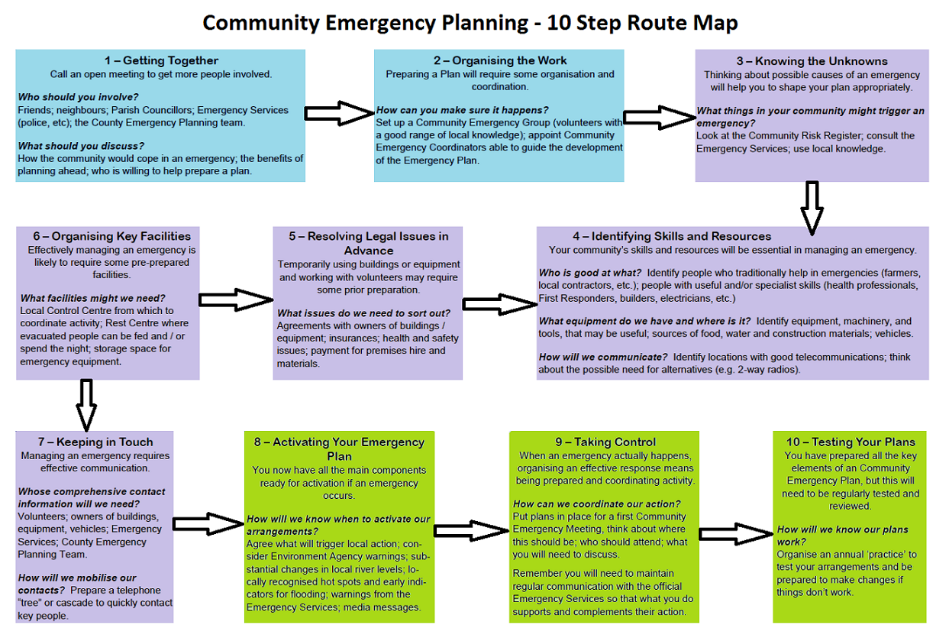

**The Community**

**Emergency Response Plan Template**

**is in a separate document that can be obtained by contacting ccuadmin@dwfire.org.uk**

**The following are examples of risk specific Action plans to help you when thinking about how to respond to particular risks.**

**Once developed for your community these can be placed as an Annex to your**

**Community Emergency Response Plan**

|  |  |  |  |
| --- | --- | --- | --- |
|  | **EXAMPLES OF RISK SPECIFIC ACTION PLANS** |  |  |
|  | Actions for Pandemic Flu |  | Annex A |
|  | Actions for Snow Plan |  | Annex B |
|  | Actions for Loss of Utilities |  | Annex C |
|  | Actions for Flood Plan:- |  | Annex D |
|  | EA – MAP of Flood Warning Area information |  |  |
|  | EA – Flood Warning Messages for the Area |  |  |
|  | Triggers/Local Authority actions/Community Actions |  |  |
|  | Lead Flood Warden Action Card |  |  |
|  | Area Flood Warden Action Card |  |  |
|  | Who does what in a flood emergency |  |  |
|  | Managing Flood – Who does what? |  |  |
|  | EA – Checklist for the completion of a flood plan |  |  |

**PANDEMIC FLU PLAN**

# PANDEMIC FLU – is the UK’s highest risk. In a severe outbreak, up to 750,000 people could die of flu in the UK.

TRIGGER – PANDEMIC DECLARED BY WORLD HEALTH ORGANISATION

1. Convene Emergency Team – include health care professionals if possible. Make this Team larger than others, since during a full pandemic up to half the Team could catch the flu.

2. Contact details for

- Volunteers who can collect and drop-off prescriptions, collect food, etc.

- Local Link Volunteers (provide transport for people without transport)

- Organisations for identifying vulnerable people

- Local GP surgeries

- Local pharmacy

- Nearest 24 hour pharmacy

3. Preparatory Work

- In Autumn, distribute information about ‘flu jabs’ on local website and newsletter

- Share plans with the community

4. During Pandemic

- Put up NHS posters, and share with churches, village shop, etc.

- Consider cancelling public gatherings and meetings, as advised by the NHS

- Activate volunteers to help people living alone with:

Dropping off food

Dropping off prescriptions / anti-viral flu drugs

Looking after pets

Keeping in touch with infected people through email /phone.

**SNOW PLAN**

TRIGGER – ALERTS FROM THE MET OFFICE

Severe Weather Warning Service (NSWWS) Alerts/Warnings for snow for your area

1. Map showing

- Roads that are gritted by the Local Authority

- Local areas at most risk (tight bends, steep hills, route to school, etc.)

- Priority areas that will be gritted by Parish / Town Council

- Location of grit bins

- Location of 1 Tonne salt

- Location of farmers who can help

2. Contact details

- Snow warden volunteers

- Farmers with gritting equipment and snow ploughs

- Local Authority Response Teams

- 4 x 4 drivers

- Voluntary groups that are in contact with vulnerable people

3. Preparatory work

- Apply for 1 Tonne for salt

- Check grit bins, and contact Severe Weather team requesting grit if necessary.

- Ask farmer to confirm their equipment can be used

- Put article in Winter edition of Parish newsletter

4. Actions to be taken

NOTE – Specify WHO is responsible for each action, and when they need to do it.

Call meeting of Emergency Team

Ensure warnings on website

Notify farmer to mobilize salt stores

Ask snow volunteers to grit pavements

Refill grit bins from 1 Tonne salt

# LOSS OF UTILITIES

TRIGGER – LOSS OF ELECTRICITY AND WATER

1) Electricity – is distributed in Dorset by Scottish and Southern Energy and Western Power Distribution

i). Preparation:

* Download ‘Power Track’ App for smartphones (shows outages on a map)
* Create <http://www.ssepd.co.uk/Powertrack/> as a favourite on your web browser
* Encourage vulnerable people to join the ‘Priority Services Register’ 0800 294 329
* Contact voluntary groups to check welfare of vulnerable people during an outage.
* Consider opening a rest centre in an outage, if prolonged period.

ii) . In an outage:

* Call 0800 072 7282 for information (0345 072 1905 from a mobile phone)

2) Water – is supplied by:

Bournemouth Water

* Check website for planned works <http://www.sembcorpbw.co.uk/>
* Call 01202 590059 to report problems
* Encourage vulnerable people to join ‘Customer Care Extra’ by calling 01202 590059
* Contact voluntary groups to check welfare of vulnerable people

Wessex Water

* Keep <http://www.wessexwater.co.uk/> as a favourite on your web browser
* Emergencies and operational problems Telephone 0345 600 4 600
* Encourage vulnerable people to join the ‘Customer Care Plus’ 0345 600 3 600

**The following pages include actions for a Flood Plan and example documents of local flood mapping information and triggers for local authority and**

**community response actions.**

**These complement the Environment Agency Community Flood Template that can be found at** [**https://www.gov.uk/government/publications/community-flood-plan-template**](https://www.gov.uk/government/publications/community-flood-plan-template)

**Working together as a community or group to complete a plan will help you respond quickly when flooding happens.**

**It can help you decide what practical actions to take before and during a flood, helping reduce the damage**

**flooding can cause.**

# FLOOD PLAN

TRIGGER – LOCAL FLOOD ALERT FROM ENVIRONMENT AGENCY, ALONG WITH MET OFFICE NSWWS FOR ALERT/WARNING FOR HEAVY RAIN FOR YOUR AREA OR LOCAL KNOWLEDGE

1. Map showing

* - Areas at risk of flooding
* - Drains and gulley’s
* - Location of sand stores
* - Roads, bridges and crossing points that are at risk of closing

2. Contact details of

- Flood wardens (see Action Cards overleaf for Lead Flood Warden and Area - Flood Warden)

- Farmers who can assist

- Local Highways Engineer (Dorset County Council)

- Flood and Drainage Team

- Environment Agency

- Voluntary Groups who are in touch with vulnerable people.

3. Preparatory work

- Contact Local Highways team in late summer requesting clearing of drains, etc.

- Promote Environment Agency Flood Line registration through Parish newsletter in summer edition.

- Apply for 1 Tonne of sand, bags, road signs and gel sacs.

- Write to local barracks to ask if they are happy to assist when Parish is in trouble.

4. Actions when a flood warning has been issued

NOTE – Specify WHO is responsible for each action, and when they need to do it.

- Flood warning to check vulnerable properties

- Update website

- Notify Local Council of number of homes and businesses at risk, and those that have been flooded.

******

|  |  |  |  |
| --- | --- | --- | --- |
| **Message** | **What it means** | **When is it issued** | **Relevant code for the Area** |
| 3 | Flooding of low lying roads, coast and land is possible. | Two days to two hours in advance of flooding | **111WACWCD**  West Coast of Dorset   * triggered by tidal forecast   **111111WAFWDRS**  West Dorset Rivers and Streams   * triggered by river gauges across West Dorset (local gauge at Up Lyme) |
| FLOOD WARNING_COL_STRAP | Flooding of properties is expected | One day to half an hour in advance of flooding | **111FWTLYMH010**  Lyme Regis Harbour   * triggered by coastal forecast base on tide height and waves   **111FWFLIM101**  River Lim from Up Lyme to Lyme Regis (riverside properties)   * triggered from Up Lyme gauge   **11FWFLIM102**  River Lim from Up Lyme to Lyme Regis   * triggered from Up Lyme gauge |
| SEVERE FLOOD WARNING_COL_Eng_STRAP | Flooding of properties, danger to life, severe disruption to services and transport | When flooding poses a significant risk to life | **111FWTLYMH010**  Lyme Regis Harbour   * triggered by coastal forecast base on tide height and waves   **111FWFLIM101**  River Lim from Up Lyme to Lyme Regis (riverside properties)   * triggered from Up Lyme gauge   **11FWFLIM102**  River Lim from Up Lyme to Lyme Regis   * triggered from Up Lyme gauge   (It is likely that the severe flood warning for the river would be issued after the two flood warnings have been issued) |

**What triggers the Local Authority and the Community Response Group to respond to a flooding incident and what actions are taken?**

|  |  |  |
| --- | --- | --- |
| **Triggers** | **Local Authority Actions** | **Community Actions** |
| **Met Office Severe Weather Warning**   * Severe weather is forecast from the Met Office. * Individual properties may be affected by surface water flooding * Flooding of low lying land and roads adjacent to the river   **Local monitoring / triggers**: | * Monitoring by Duty Engineer * Possible discussion with Environment Agency / Met Office based on Heavy Rainfall Alerts * Duty Engineer responds to calls (likely to be surface water related at this stage | * Flood Coordinator telephones flood wardens * Flood Wardens monitor Environment Agency’s website (River Levels on the Internet) & Met Office website * Monitoring of areas prone to surface water flooding * Report any local flooding to Local Authority Duty Engineer |
| ***INSERT AREA CODE & AREA***  **Area affected**:  **Local monitoring / Triggers:** | * Duty Engineer considers if any action is required based on known risks and past experience * Discussions with Environment Agency duty teams * Harbour master and Coastguard monitor situation as necessary. | * **Community flood plan activated** * Flood Coordinator calls Flood line for further information * Flood Coordinator contacts flood wardens and requests a flood patrol * Flood Wardens monitor local water levels, drains. * Flood Wardens inform vulnerable residents of flood alert if local triggers give concern * Flood Wardens report back to Flood Coordinator * Flood Coordinator provides feedback to Environment Agency / Local Authority Duty Teams * Flood Coordinator liaises with Town Emergency Committee |
| ***INSERT AREA CODE***  ***INSERT AREA* - Rivers and Streams**  **Area Affected:** riverside path  **Local monitoring / Triggers:** | * Duty Engineer considers if any action is required based on known risks and past experience * Discussions with Environment Agency duty teams * Duty Engineer responds to calls (likely to be surface water related at this stage |
| ***INSERT AREA CODE***  ***INSERT AREA-* Harbour**  **Area Affected: Buildings along the Harbour**  **Local Trigger:** | * Liaise / check extent with Environment Agency * Liaise with flood coordinator / town emergency group/committee * Coordinate response by local council work force * Respond to calls from the public * Alert appropriate staff within the council and emergency planning teams | * **Community Emergency Plan Activated** * Community Response Group convened * Community Response Group coordinate activities of flood wardens * Flood wardens monitor local water levels & provide feedback to town emergency committee. * Flood Wardens inform vulnerable residents of Flood Warning * Flood wardens assist vulnerable residents to make preparations to cope with the onset of flooding * Community Response Team liaise with flood wardens to coordinate distribution of emergency gel sacs / sandbags * Community Response Group provide feedback to local feedback on conditions to Environment Agency / Local Authority * Emergency rest centres contacted in preparation of event escalating (particularly if *INSERT AREA CODE is issued*) |
| ***INSERT AREA CODE***  **River? From? To? (riverside properties**  **Areas affected: Properties adjacent to the river, along ?*INSERT STREET NAMES***  **Local Trigger:** |
| ***INSERT AREA CODE***  **River? From? To?**  **Areas affected: Properties adjacent to the river, along *INSERT STREET NAMES***  **Local Trigger:** |
| ***INSERT AREA CODE* & AREAS**  The severe flood warnings for? can be activated from either flood warning area and would cover all affected areas | * Liaise with Environment Agency, Dorset Police, Fire & Rescue, other local councils and partner agencies as to severity, extent expected and timings. * Activate Emergency Response Plans: * Local Authority Liaison Officer to site * Consider activating rest centre(s) via Local Authority Duty Emergency Planning Officer * Provide assistance to Dorset Police at the Evacuation Assembly Point and/or in Rest Centres | * Community Response Group liaise with Local Authority Emergency Planning/ Emergency services * Community Response Group provide local feedback on conditions to Environment Agency / Highways & Local Authority * Flood wardens assist emergency services by providing local knowledge about conditions * Flood Wardens support council emergency teams with evacuations, rest centre set up |

|  |
| --- |
| **Action Card 1 - *INSERT STREET/AREA* Lead Flood Warden** |
| **Flood Alert**   * Ring Deputy Flood Wardens with information * Phone Flood line (0345 988 1188 – quick dial 045122) for further information * Stay safe * Monitor local drains and water levels * Monitor river levels (visually and through river levels on the internet) * Report concerns to the Environment Agency’s Incident Communication Service (0800 80 70 60) * Report concerns about drains to Wessex Water (0345 600 4 600) * Provide information to vulnerable residents |
| **Flood Warning**   * **Stay Safe** * Work with deputy flood wardens to inform residents that flood warning has been issued * Encourage residents to put any flood protection products * Monitor local drains and water levels * Monitor river levels * Report concerns to the Environment Agency’s Incident Communication Service(0800 80 70 60) - if property flooding is imminent as to speak to the Blandford Flood Incident Duty Officer * Phone Flood line (0345 988 1188 – quick dial 166024 for further information * Report concerns about drains and surface water flooding to Wessex Water (0345 600 4 600) * If property flooding is occurring liaise with the Borough/District Council in evacuation of residents to rest centres * Provide local intelligence to the emergency services * Monitor extent and time of flooding to provide post event feedback to the Environment Agency |
| **Severe Flood Warning**   * **Stay safe** * Help vulnerable residents prepare for evacuation * Provide local support and intelligence to emergency services in evacuation procedures * If safe to do so monitor extent of flooding and provide feedback to Borough/District Council / Emergency services / Environment Agency |

|  |
| --- |
| **Action Card 2 - *INSERT STREET/AREA* – Area Flood Warden** |
| **Flood Alert**   * Check situation with flood emergency committee * Phone Flood line (0345 988 1188 – quick dial 045122) for further information * Monitor local drains and water levels * Monitor River Levels (visually and through river levels on the internet) * Report concerns to Lead Flood Warden * Report concerns about drains to Lead Flood Warden * Provide information to vulnerable residents |
| **Flood Warning**   * **Stay safe** * Work with flood emergency committee to inform residents that flood warning has been issued * Encourage residents to put any flood protection products * Monitor local drains and water levels * Monitor river levels * Report concerns about river levels, surface water build up, drain or sewage problems to the lead flood warden * If property flooding is occurring support flood warden in liaison with Borough/District Council * Council evacuation of residents to rest centres * Provide local intelligence to the emergency services * Monitor extent and time of flooding to provide post event feedback to the Flood emergency committee & Environment Agency |
| **Severe Flood Warning**   * **Stay safe** * Help vulnerable residents prepare for evacuation * Provide local support and intelligence to emergency services in evacuation procedures * If safe to do, so monitor extent of flooding and provide feedback to Borough/District Council/Emergency services/Environment Agency |

**Who does what in a flood emergency?**

**Police**

• takes an overall co-ordination role during an incident.

**Fire and Rescue Service**

• responds to all emergency incidents as required;

• assists the public where a need is identified and the use of Fire Service

personnel and equipment is required.

This lists the principle actions of each organisation. It may not always be possible

for all actions to be carried out during a flood event.

Responding organisations have limited resources so may not be able to provide

assistance in all circumstances. In such cases the owners and occupiers need to

be aware that they should make their own arrangements to protect their property

from flooding. This should be clearly stated in the plan.

**County Council and Unitary Authorities**

• co-ordinates emergency arrangements;

• maintains safe conditions on the roads;

• puts flood warning signs on the highway;

• organises road closures and traffic diversions;

• clears blockages on highway drainage systems;

• may take action to protect property from flooding by water from the

highway where there is a failure of the highway drainage system.

**Lead Local Flood Authorities (LLFA)**

• overall management responsibility for surface water, groundwater and ordinary

watercourse flooding;

• develops and actions the local flood risk management strategy for local sources of

flooding;

• receives and records details of flooding at post incident / recovery stage;

• investigates flooding incidents in its area;

• maintains a register of structures or features which have a significant effect

on flood risk within their area of responsibility

• regulates activities affecting flow in ordinary watercourses.

**Unitary Authorities, District and Borough Councils**

• co-ordinates emergency response for its own area;

• issues flood warnings (by local agreement with Environment Agency);

• provides emergency assistance including providing sandbags;

• clears blocked watercourses (Land Drainage Act powers);

• deals with environmental health issues ,including pollution;

• clears blocked road channels and gully gratings and street cleaning;

• runs emergency planning support groups.

**Environment Agency**

issues flood warnings for flooding from rivers, the sea and groundwater;

• receives and records details of flooding incidents;

• monitors the situation and advises other organisations;

• deals with emergency repairs and blockages on main rivers and own structures;

• responds to pollution incidents;

• advises on waste disposal issues.

**Water companies**

• clears blockages in public sewers;

• may take action to protect property from flooding by water from the public

water mains or discharges from the public sewerage systems.

**Electricity, gas and telecommunication companies**

• attends to emergencies relating to their service at properties where life is at

risk as a result of flooding;

• attends to flooding emergencies at their own serviced installations.

**Large industrial companies**

• protects own premises and installations;

• provides resources which could be hired.

**Property owners**

• moves to a safe area if life at risk;

• prevents water from entering property if possible;

• switches off electricity and gas supplies at mains;

• moves valuable possessions above areas liable to be flooded.

**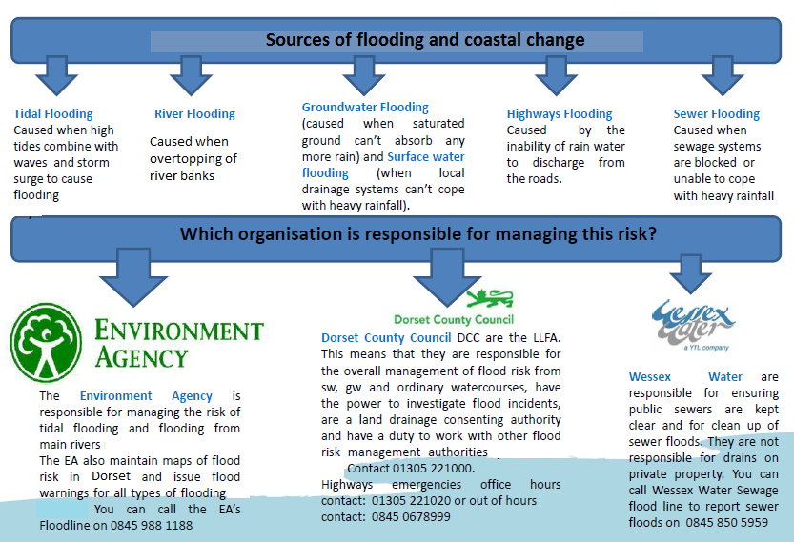**

**Checklist for the completion of a flood plan**

|  |  |
| --- | --- |
| **Does the plan include?** | **✓** |
| Map/list of properties liable to flood |  |
| Locations at risk of flooding |  |
| Details of what triggers the community flood plan (flood warnings or other triggers) |  |
| List of vulnerable properties |  |
| List of vulnerable people |  |
| Details of the Flood Plan coordinator and Flood group |  |
| Flood line Warnings Direct details and registrations (if applicable) |  |
| Roles & responsibilities of volunteers, local authority, Environment Agency etc. |  |
| Useful contact telephone numbers during an event |  |
| Evacuation Centre identified & key holder details |  |
| Key community skills identified |  |
| Community store/ community resources identified |  |
| Clear action plan (Before, during and after a flood actions) |  |
| Method of recording information during a flood included |  |
| A date when the emergency store contents will be checked |  |
| A date when contact details etc. will be checked and updated |  |
| Has the plan been seen by the Local Authority Emergency Planner? |  |
| The plan has been tested |  |

**Dorset Command & Control Response arrangements**

Provision of effective multi-agency support to communities and individuals in a crisis is ensured by integrated emergency response and recovery arrangements. Communities should be aware of the Dorset command and control arrangements adopting the civil contingencies approach and which are included in multi-agency and individual agency emergency response plans. Find out about local plans <https://www.gov.uk/local-planning-emergency-major-incident>

Although there are no statutory responsibilities for communities to plan for, respond to, or recover from emergencies, it is good practice to identify hazards and make simple plans on how they could respond to them.

**Community Response Teams (where in place)**

The Community Response Teams consists of a Team Chair, Community Response Coordinator and members of the Team e.g. Local Flood Warden, Snow Warden, Flu Friends etc.

Members of the Team would form to assist the activation of the Community Emergency Response Plan to assist the emergency services and local authority wherever possible, prior to, during and after an emergency event.

**Local Authority Support Functions**

**The Local Authority** provides a 24-hour contact to act as a first point of contact for the local authority for emergencies and disruptions all year round.

**Please note that this does not negate the requirement to call 999.**

The Local Authority would ensure coordination and support of local authority functions as considered necessary. This could be:

* Deployment of a Local Authority Liaison Officer at the scene and or establishment.
* Deployment of local authority welfare support at Rest Centres
* Deployment of Property Officers where there is structural damage
* Deployment of Highways personnel in order to ensure safe access and egress of emergency services to establishments in emergency situations.
* Deployment of vehicles and transport operatives to ensure speedy evacuation for those to a place of safety
* Ensuring effective communications and consistency of information between key emergency responders and the community
* Coordinating Voluntary Agency support to communities.

**Dorset Civil Contingencies Unit (CCU)**

The Dorset Civil Contingencies Unit has a responsibility to support, assist and advise organisations forming part of the Dorset Local Resilience Forum in preparing for, responding to and recovering from any incident/emergency/

disruptive challenge that requires a multi-agency response.

The CCU Duty Officer is available 24/7 and can be called upon by the emergency services to invoke procedures and put in place arrangements in accordance with the relevant Dorset LRF emergency plans and partnership arrangements.

See diagram at Fig1

**Multi-agency Tactical Coordination Group (TCG)**

Dependent on the severity of an emergency situation, whereby formal coordination is required, a Multi-agency TCG (to include representation of emergency services, health bodies and local authorities) would convene. Here, tactical coordination of an emergency response to the situation will focus on:

* + - Health and safety of the public and personnel
    - Assess significant risks
    - Determine priorities for allocating available resources
    - Plan and coordinate how and when tasks will be undertaken
    - Obtain additional resources if required

**Multi-agency Strategic Coordination Group (SCG)**

Where an emergency situation has significant impact on the community, substantial resource implications, involves a large number of organisations or lasts for an extended duration, it may be necessary to assemble a multi-agency SCG. This group brings together all relevant strategic representatives from the emergency services, health and local authorities. The SCG will:

* Determine and promulgate a clear strategic aim and objectives and review them regularly;
* Establish a framework for the overall management of the emergency situation;
* Prioritise requirements of the emergency responders and allocate personnel and resources accordingly;
* Formulate and implement media handling and public communication plans; and
* Direct planning and operations beyond the immediate response in order to facilitate the recovery process.

Should it be considered that there are significant recovery implications, the SCG may commission the establishment of a Recovery Coordinating Group (RCG) chaired by the lead council.

Further strategic issues that may require the formation of specific groups include:

* Humanitarian assistance for those affected by the emergency;
* Facilitating enquiries and investigations;
* Visits by VIPs; and
* International and diplomatic dimensions.

SCGs will develop a strategy for providing warnings, advice and information to the public and dealing with the media

**Recovery Coordinating Groups**

Recovery from an emergency can be a complex and long-running process. A resilient community will not only be better prepared to respond at the time of an emergency, but will be better equipped to recover in the long-term.

The Dorset LRF partners have arrangements in place to support recovery arrangements for those communities affected and essential groups will convene as necessary. Refer to the LRF Recovery Plan, available from <https://www.dorsetforyou.com/emergencies/bournemouth-dorset-and-Poole-local-resilience-forum-recovery-plan>

# Useful Links

## Local Resilience Forum

<http://www.dorsetfire.gov.uk/working-with-us/partnerships/statutory-partnerships/local-resilience-forum/>

Local Resilience Forums (LRFs) aim to plan and prepare for localised incidents and catastrophic emergencies. They work to identify potential risks and produce emergency plans to either prevent or mitigate the impact of any incident on their local communities.

***Preparing for emergencies: find out about local plans***

<https://www.gov.uk/local-planning-emergency-major-incident>

***Community Emergency Response Plan Template***

***TBA***

## National Risk Register

<https://www.gov.uk/government/publications/national-risk-register-for-civil-emergencies-2015-edition>

The National Risk Register (2015 edition) provides a government assessment of the likelihood and potential impact of civil emergency risks.

## Environment Agency Community Flood Plan Template

<https://www.gov.uk/government/publications/community-flood-plan-template>

<https://www.gov.uk/prepare-for-a-flood>

Prepare for a flood and get help during and after.

Floodline: 0345 9881188

***Met Office***

Website: <http://www.metoffice.gov.uk/>

Tel: 0370 900 0100

Email: [enquiries@metoffice.gov.uk](mailto:enquiries@metoffice.gov.uk)

For information on weather including forecasts, warnings and community resilience

***Met Office and Community Resilience***

<http://www.metoffice.gov.uk/publicsector/resilience/community-resilience>

<http://www.metoffice.gov.uk/learning/get-ready-for-winter/communities>

## 

## British Red Cross

<http://www.redcross.org.uk/What-we-do/Preparing-for-disasters/How-to-prepare-for-emergencies>

The pages in this section provide information on the simple precautions you can take to prepare for a range of emergency situations, along with advice on how to cope if they happen.

## Royal Voluntary Service

<http://www.royalvoluntaryservice.org.uk/>

0845 608 0122

Information about the services RVS provide.

## St John Ambulance

<https://www.sja.org.uk/sja/what-we-do/emergency-response.aspx>

08700 104950

Information about how first aid training can make a difference to people in an emergency.

## RSPCA

<http://www.rspca.org.uk/whatwedo/yourlocal>

0300 1234 555

The RSPCA has put together some guidelines so that you can be prepared to get your animals to safety in the event of flooding.

## Radio Amateurs’ Emergency Network (RAYNET)

<http://www.raynet-uk.net/>

The UK’s national voluntary communications service provided for the community by licensed radio amateurs.

***Preparation and planning for emergencies: responsibilities of responder agencies and others.***

<https://www.gov.uk/guidance/preparation-and-planning-for-emergencies-responsibilities-of-responder-agencies-and-others>

## Community resilience: resources and tools.

<https://www.gov.uk/government/publications/community-resilience-resources-and-tools>

Online resources to enable individuals, communities and organisations that support them to take part in emergency preparedness activities.

# Glossary

### **Community Resilience**

Communities and individual harnessing local resources and expertise to help themselves during an emergency, in a way that complements the work of the emergency services.

### **Community Risk Register**

An assessment of local risks that have been identified within a Local Resilience Forum area. It is written, maintained and published by the Local Resilience Forum.

### **Emergency**

An event or situation which threatens serious damage to human welfare in a place in the United Kingdom; the environment of a place in the United Kingdom; or the security of the United Kingdom or of a place in the United Kingdom.

Emergencies can also affect you at home, for example house fires, broken down boilers, burst pipes etc.

### **Local emergency responders**

Organisations that respond to emergencies in your area. They include the fire, police and ambulance services, as well as your local authority and other organisations.

### **Local Resilience Forum (LRF)**

A group formed in police area boundaries of England and Wales by key local emergency responders and specific supporting agencies for the purpose of fulfilling their duties under the Civil Contingencies Act 2004.

### **National Risk Register**

A report produced by the Cabinet Office which outlines the Government’s assessment of significant potential risks to the United Kingdom.

### **Rest Centre**

A building which is designated by a local authority for the temporary accommodation of evacuees. This may include overnight accommodation.

Risk

A measure of the likelihood and impact of a potential emergency.



**Prepared by**

**Dorset Civil Contingencies Unit**

**Police HQ**

**Winfrith**

**Dorset**

**DT28DZ**

**Telephone: 01305 229044**

**Email: ccuadmin@dwfire.org.uk**